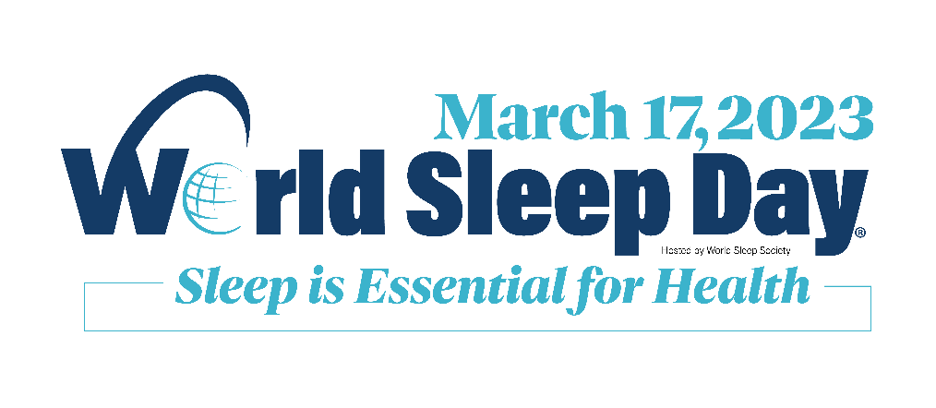

World Sleep Day 2023
World Sleep Day 2023 will take place on Friday, March 17 and incorporate the slogan Sleep is Essential for Health. Just like eating well and exercising, sleep is a behavior that is foundational to one’s physical, mental, and social well-being.
Members of World Sleep Society, sleep experts, and community health advocates in over 70 countries will be organizing local, regional and national activities to promote sleep health. Join us!
Additional information, messaging, and World Sleep Day logos are included in the following toolkit. Follow worldsleepday.org and sign up for email updates to receive more tips, tools, and resources as Friday, March 17 approaches.

What is World Sleep Day?
Created and hosted by World Sleep Society, World Sleep Day is an internationally recognized event that builds connections and raises sleep health awareness among researchers, health care workers, patients, and the public. Participants from each of these stakeholder groups organize sleep health awareness activities in their local clinics, institutions, companies, and communities.
Activity organizer submit their activities to the official website of World Sleep Day at worldsleepday.org. Submitting your activity helps both to promote it and to save it for the historical record. Submitted activities are automatically considered for the Distinguished Activity Award, an annual award distributed to select excellent activities as determined by the World Sleep Day Committee. Browse our list of award-winning activities for inspiration to organize your own!
The World Sleep Day Committee is co-chaired by Dr. Lourdes DelRosso (United States) and Dr. Fang Han (China).

Commentary on the 2023 Theme from World Sleep Day Leadership
“Just because sleep is a natural behavior does not mean that sleep should be taken for granted.”
–Fang Han, MD, Co-Chair of World Sleep Day 2023
“People should think about sleep like they do other important healthy behaviors such as exercise – as something to reflect upon and, when appropriate, improve so that one can feel better and remain healthier over time.”
–Lourdes DelRosso, MD, PhD, Co-Chair of World Sleep Day 2023
“Our patients and people of all ages across the world can enhance their overall health and well-being by prioritizing sleep and embracing strategies to improve sleep and circadian health. The more our members, activity organizers and the media can share evidence-supported knowledge about sleep and circadian health, the better.”
–Phyllis C. Zee, MD, PhD, President of World Sleep Society

Key Messaging for World Sleep Day 2023
Key Message 1: Healthy sleep is more than simple duration.
Three elements of good quality sleep are:

- Duration: The length of sleep should be sufficient for the sleeper to be rested and alert the following day.
- Continuity: Sleep periods should be seamless without fragmentation.
- Depth: Sleep should be deep enough to be restorative.

Key Message 2: Sleep is a pillar of human health.
The World Health Organization defines “health” as “a state of complete physical, mental and social well-being and not merely the absence of disease or infirmity.” Decades of research have demonstrated the significance of sleep for physical, mental, and social well-being.
Sleep is essential to health. It is a critical pillar of health, like nutrition and physical activity [1, 2].
- Sleep helps support memory and learning [3].
- Sleep helps clear waste from the brain and promote brain health [4].
- Sleep supports brain health, and brain health supports sleep [5].
- Sleep supports immune health, and immune health supports sleep [6].
- Sleep helps the immune system to clear bacteria and viruses [6].
- Sleep helps to recycle old cells and maintain our bodies and energy levels [7].
- Sleep health is unevenly distributed across populations and is an important target for improving health equity [2].
Poor sleep health can have multiple significant impacts on human health.
- Poor sleep has been linked to obesity [8], diabetes [9], coronary artery disease, and cardiovascular mortality [10].
- Poor sleep can lower immune response, creating greater susceptibility to infections that further reduce sleep quality [4].
- Certain sleep disorders like obstructive sleep apnea and rapid eye movement sleep behavior disorder are associated with cognitive impairment [11], dementia [12], risk of seizures [13], and increased risk of stroke [14].
- Poor sleep can result in reduced reaction times, impaired judgment, and cognitive impairment similar in effect to alocohol intoxication [15].
- Drowsiness can impair safe driving even if the driver does not fall asleep [16].
The European Academy of Neurology and World Health Organization have recognized the importance of sleep to brain health. In 2022, the American Heart Association added sleep to its list of eight essential factors for cardiovascular health.

Official Logos for World Sleep Day 2023
World Sleep Day logos are available for download on worldsleepday.org/toolkit. The World Sleep Day logo may be used in conjunction with an awareness activity. Companies and organizations must receive written approval from World Sleep Society before using the logo. A formal agreement may be required for a company to use the World Sleep Day name, logo, or other content in their materials. All usage of the World Sleep Day logo must conform to the World Sleep Day Brand Guidelines.

Media Contact and Expert Availability for Interviews & Commentary
Select members of World Sleep Society may be available to take your request for an interview or commentary. Sleep researchers and clinicians across 80+ countries comprise the World Sleep Society membership. If you would like to connect with a sleep expert for a brief interview or commentary, contact World Sleep Society at info@worldsleepsociety.org.
In your request for a sleep expert, include:
- Your publication, network, or platform
- Your topic of interest
- Your intended audience for the piece
- Your availability in multiple time slots in the coming weeks
Our members are volunteers who often have busy clinical and research schedules, so scheduling ahead of time helps greatly when securing an interview. World Sleep Society and its representatives do not endorse or recommend any particular services or products.

Speaker Availability for Your Event
World Sleep Society experts can also be available to speak at a public or private event on a topic of sleep health. A formal World Sleep Day agreement between the event organizer and World Sleep Society may be required. For more information, see worldsleepsociety.org/sponsor or contact info@worldsleepsociety.org.

Additional Resources
World Sleep Society produces educational content regarding sleep health across multiple programs in addition to World Sleep Day. Find some examples below and incorporate them into your World Sleep Day content and messaging.

Healthier Sleep Magazine – a magazine written and reviewed by sleep experts for the public. Issue topics have included COVID-19, various sleep disorders, travel & sleep, and more. Find all the Healthier Sleep content and complete issues at healthiersleepmag.com.

Sleep Expo 2019 – public lectures from international sleep experts. The Sleep Expo was held in Vancouver in 2019. Find video recordings of all the public lectures on YouTube. Below are just some of the topics discussed by experts:
- Insomnia treatments and therapies
- Parkinson’s, dementia, and the elderly
- Sleep apnea diagnosis and treatments
- Can my dentist help me sleep?
- How sleep can affect your health
- Sleep walking, night terrors, and nightmares
- Effect of sleep on sports performance and sports injuries

The History of World Sleep Day
The first World Sleep Day was held on March 14, 2008 under the slogan “Sleep Well, Live Fully Awake.” The annual awareness day is held the Friday before Spring Vernal Equinox.
Previous Slogans
- “Sleep Well, Live Fully Awake” – March 14, 2008
- “Drive Alert, Arrive Safe” – March 20, 2009
- “Sleep Well, Stay Healthy” – March 19, 2010
- “Sleep Well, Grow Healthy” – March 18, 2011
- “Breathe Easily, Sleep Well” – March 16, 2012
- “Good Sleep, Healthy Aging” – March 15, 2013
- “Restful Sleep, Easy Breathing, Healthy Body” – March 14, 2014
- “When Sleep is Sound, Health and Happiness Abound” – March 13, 2015
- “Good Sleep is a Reachable Dream” – March 18, 2016
- “Sleep Soundly, Nurture Life” – March 17, 2017
- “Join the Sleep World, Preserve Your Rhythms to Enjoy Life” – March 16, 2018
- “Healthy Sleep, Healthy Aging”– March 15, 2019
- “Better Sleep, Better Life, Better Planet”– March 13, 2020
- “Regular Sleep, Healthy Future”– March 19, 2021
- “Healthy Sleep, Sound Mind, Happy World” – March 18, 2022

References
[1] Cassidy S, Chau JY, Catt M, et al. Cross-sectional study of diet, physical activity, television viewing and sleep duration in 233,110 adults from the UK Biobank; the behavioural phenotype of cardiovascular disease and type 2 diabetes. BMJ Open 2016; 6: e010038
[2] Hale L, Troxel W, Buysse DJ. Sleep Health: An Opportunity for Public Health to Address Health Equity. Annu Rev Public Health. 2020;41:81-99. doi:10.1146/annurev-publhealth-040119-094412
[3] Reyes-Resina I, Samer S, Kreutz MR, et al. Molecular Mechanisms of Memory Consolidation That Operate During Sleep. Front Mol Neurosci 2021; 14: 767384. 2021/12/07. DOI: 10.3389/fnmol.2021.767384
[4] Nedergaard M and Goldman SA. Glymphatic failure as a final common pathway to dementia. Science 2020; 370: 50-56. 2020/10/03. DOI: 10.1126/science.abb8739
[5] Ju YE, Lucey BP and Holtzman DM. Sleep and Alzheimer disease pathology--a bidirectional relationship. Nat Rev Neurol 2014; 10: 115-119. 2013/12/25. DOI: 10.1038/nrneurol.2013.269
[6] Haspel JA, Anafi R, Brown MK, et al. Perfect timing: circadian rhythms, sleep, and immunity - an NIH workshop summary. JCI Insight 2020; 5 2020/01/17. DOI: 10.1172/jci.insight.131487
[7] Min S, Masanovic B, Bu T, et al. The Association Between Regular Physical Exercise, Sleep Patterns, Fasting, and Autophagy for Healthy Longevity and Well-Being: A Narrative Review. Front Psychol 2021; 12: 803421. 2021/12/21. DOI: 10.3389/fpsyg.2021.803421
[8] Covassin N, Singh P and Somers VK. Keeping Up With the Clock: Circadian Disruption and Obesity Risk. Hypertension 2016; 68: 1081-1090. 2016/09/14. DOI: 10.1161/HYPERTENSIONAHA.116.06588
[9] Itani O, Jike M, Watanabe N, et al. Short sleep duration and health outcomes: a systematic review, meta-analysis, and meta-regression. Sleep Med 2017; 32: 246-256. 2016/10/17. DOI: 10.1016/j.sleep.2016.08.006
[10]Covassin N and Singh P. Sleep Duration and Cardiovascular Disease Risk: Epidemiologic and Experimental Evidence. Sleep Med Clin 2016; 11: 81-89. 2016/03/15. DOI: 10.1016/j.jsmc.2015.10.007
[11] Lim AS, Kowgier M, Yu L, et al. Sleep Fragmentation and the Risk of Incident Alzheimer's Disease and Cognitive Decline in Older Persons. Sleep 2013; 36: 1027-1032. 2013/07/03. DOI: 10.5665/sleep.2802
[12] Wennberg AMV, Wu MN, Rosenberg PB, et al. Sleep Disturbance, Cognitive Decline, and Dementia: A Review. Semin Neurol 2017; 37: 395-406. 2017/08/25. DOI: 10.1055/s-0037-1604351
[13] Bonilla-Jaime H, Zeleke H, Rojas A, et al. Sleep Disruption Worsens Seizures: Neuroinflammation as a Potential Mechanistic Link. Int J Mol Sci 2021; 22 2021/11/28. DOI: 10.3390/ijms222212531
[14] Koo DL, Nam H, Thomas RJ, et al. Sleep Disturbances as a Risk Factor for Stroke. J Stroke 2018; 20: 12-32. 2018/02/07. DOI: 10.5853/jos.2017.02887
[15] Williamson AM and Feyer AM. Moderate sleep deprivation produces impairments in cognitive and motor performance equivalent to legally prescribed levels of alcohol intoxication. Occup Environ Med 2000; 57: 649-655. 2000/09/13. DOI: 10.1136/oem.57.10.649
[16] American Academy of Sleep Medicine Board of Directors, Watson NF, Morgenthaler T, et al. Confronting Drowsy Driving: The American Academy of Sleep Medicine Perspective. J Clin Sleep Med. 2015;11(11):1335-1336. Published 2015 Nov 15. doi:10.5664/jcsm.5200

About World Sleep Society
World Sleep Society is a nonprofit organization based in the United States with a global membership representing over 80 countries. The mission of World Sleep Society is to advanced sleep health worldwide, particularly in places underserved by sleep medicine. World Sleep Society organizes a biennial international research conference for professionals, multiple professional education programs, and public awareness programs like World Sleep Day and Healthier Sleep magazine. Follow World Sleep Society at worldsleepsociety.org and on Twitter, Facebook, LinkedIn and Instagram.

