World Sleep Day in Romania, Bucharest
19th of March 2021
Regular sleep, healthy future

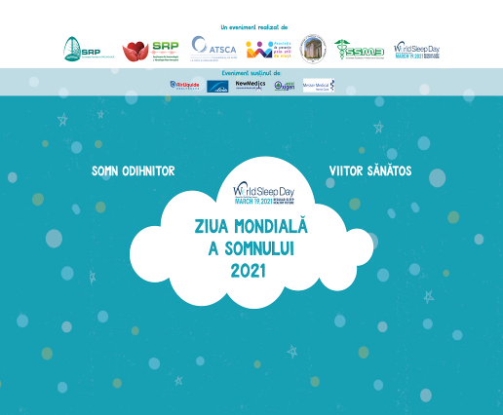

Project report

The Romanian Society of Pneumology together with the Section of Somnology and Non-Invasive Ventilation, the Association for Sleep Disorders in Children and Adolescents, the Medical Association for Prevention trough Healthy Lifestyle, University of Medicine and Pharmacy „Carol Davila” and the Medical Students’ Society of Bucharest
organized on 19th of March 2021 an event for World Sleep Day.

This year’s slogan was “Regular sleep, healthy future”

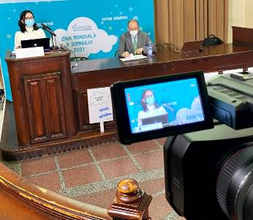

Our activities:
- Online press conference;
- A class for students;
- We have presented the results of a survey showing the pandemics effects on sleep;
The survey for young people targeted medicine students, out of which 802 have responded;
- Speakers video messages on World Sleep Day;
- Pictures with students who have sent their messages through placards with motivational messages;
- An event în Cluj Napoca;
- Experts interviews on radio and TV.

Speakers:

Prof. Dr. Florin Mihălțan, President of the Non-Invasive Somnology and Ventilation Section of the Romanian Pneumology Society
THEMES:
The adult’s sleep and its pathological interferences
Sleep and the modern life

Dr. Mihaela Oros, Member of the committee of the Section of Somnology and Non-Invasive Ventilation, president of the Association for Sleep Disorders in Children and Adolescents
THEMES:
Restful sleep for children and teenagers – interactions and benefits of the integrated recommendations
Circadian rhythm and the complexity of adaptation to the postnatal environment

dr. Anca Hâncu, nutritionist, president of the Medical Association for Prevention through Healthy Lifestyle
THEME:
About lifestyle and dreams

conf. dr. Florentina Furtunescu, vice-rector for institutional strategies and quality at U.M.F „ Carol Davila” Bucharest

The press conference was held online. The journalists were able to watch the presentations in real time and send recorded questions (audio or video) or written ones.

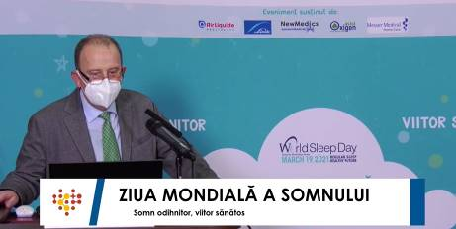

After the conference, we sent a press release and two materials with sleep tips for adults and children.
The conference was streamed live on Facebook on Romanian Society of Pneumology.

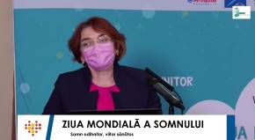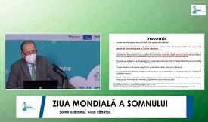
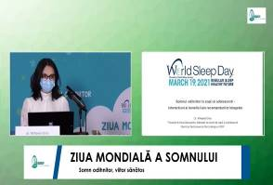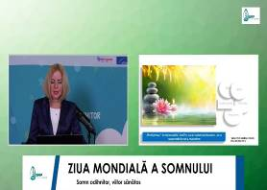

Until now - 44 features, 2.765.039 impressions (out of which 1 on national TV and 3 on radio)

The event included a class for students containing information about sleep disorders and how they can be prevented. The event took place in accordance to all the pandemic safety regulations.

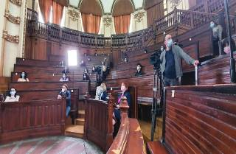

We created a survey for young people, targeting students about how the pandemic affected their sleep patterns. 802 students from the Medicine University filled in the questionnaire. Over 60% are suffering from depression, anxiety and irascibility.

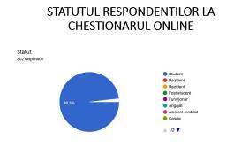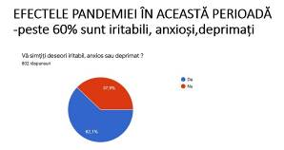

At the end of the course, the students and the speakers took pictures wearing signs with motivational messages to raise awareness on the importance of sleep in our life.

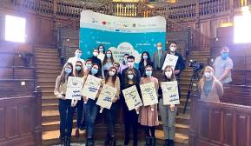

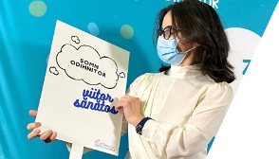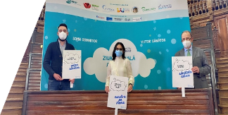

At the same time, in Cluj Napoca another activity took place to raise awareness about the fact that when your sleep isn’t restful, your health and quality of life can be affected.

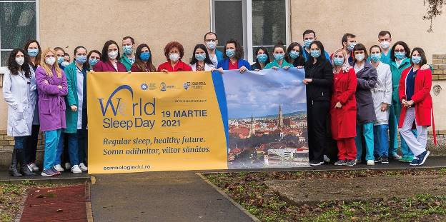

The speakers also recorded two video messages for this event.
„Regular sleep, healthy future!”



