World Sleep Day Activities
Location:- Chennai, India.
Organized by:- Sri Ramachandra Institute Of Higher Education And Research (SRIHER), Chennai
Departments involved: Physiology, Mind Body Medicine & Lifestyle Sciences, Psychiatry
Sleep is needed for physical and psychological wellbeing of a person and important for optimal biological functioning of our body. Screen time can affect the sleep quality of students in terms of subjective sleep quality, sleep latency, sleep duration, sleep efficiency, sleep disturbances. Extended periods of screen use by interaction with electronic devices that primarily deliver content via screen-based displays have been associated with multiple adverse health outcomes including obesity, type 2 diabetes, cardiovascular disease, and early mortality in adults. This pandemic has caused anxiety and worry not only among the public but among the students as well. While the spread of the virus has had far-reaching consequences, the closure of universities has led to the emergence of innovative methods of providing education that ensure the continued education of students. One of the most significant changes made was the termination of teaching sessions in-person (face to face), and most of which were substituted by video lectures or live streams. Such circumstances might have negative bearings on the students leading to high levels of anxiety and depression. Hence, SRIHER used a multipronged approach targeting schools & college students, through awareness programs, surveys about screen time usage, online discussions, e-poster contests, use of social media to promote sleep hygiene. These programs were organized by Departments of Physiology, Mind-Body Medicine & Lifestyle Sciences and Psychiatry.
- Awareness Program in schools:
- Sleep Hygiene study among school students initiated during last year World Sleep Day celebrations was extended to few more schools. However this session was done online.
  - An ongoing online Sleep survey was conducted among school going adolescents (13-15yrs) studying in class 8 & 9 from neighbouring schools after getting approval from Institutional Ethics Committee and so far 890 school children have been surveyed after getting consent from the parents and assent from the students. Their sleep quality and Sleep Hygiene practices like sleep habits, sleep disturbances; life style and stress levels, screen time usage both in weekdays and weekend etc were assessed. This study is expected to be complete by May 2021 as it has been temporarily stopped due to ongoing exams among school children. Results will be analysed, after successful data collection.
- Further to create awareness about the importance of sleep, sleep awareness videos was prepared and shared with 4 schools (Velammal Vidyalaya, Parithupettu, Jaya Jaya Shankara International School, Nasarathepttai, Poonamallee, Jawaharlal Nehru Vidhyalaya School, Kumananchavadi, Poonamallee, Jaymathaji Matriculation Higher Secondary School). This video was screened to the students during their Moral instruction hour. This video was well received and as it was online, not only the students, but their parents too got benefitted.
Sensitization on sleep among College Students
- Knowledge Awareness and Practice studies (KAP studies)
  - A cross sectional sleep study was conducted among 287 medical students (2ndyear MBBS- 4th year MBBS ) between the age group 18-25 years after getting approval from Institutional Ethics Committee during September 2020 (lock down period) at Sri Ramachandra Medical College and Research Institute (SRIHER), Porur, Chennai. Among the 287 participants, 22 students were excluded based on selection criteria, 265 students were included in the study. Electronic informed consent was obtained from the study participants after sharing audio file to them. Questionnaires as Google forms was sent through whats app groups, which clarified the various constituents such as demographic information, sleep hygiene, sleep quality, stress levels, screen time usage during weekdays and weekend. Results showed that female students had a high stress and had longer screen time and poor sleep quality when compared to their male counterparts. At the end of the survey, the 10 commandments of good sleep hygiene was shared with the students. Based on the study outcome, we decided that education programs on sleep hygiene to be conducted for medical students too.

- Active student participation through competitions:
  - Drawing competition and Slogan writing competitions (in English & regional language, Tamil) were organized for the students of our institute with the theme “Regular Sleep, Healthy Future”. These competitions attracted good participation from the students. They were judged and awarded.
- Posters designed for World Sleep Day to promote quality Sleep

 | 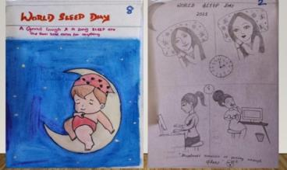
 | 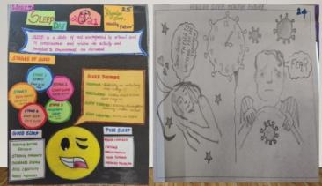
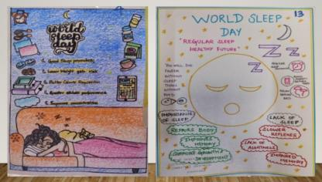 | 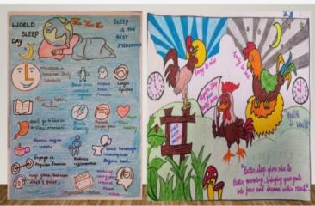
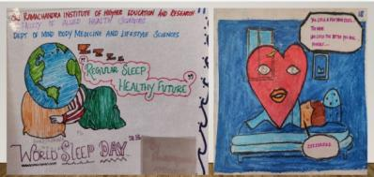 | 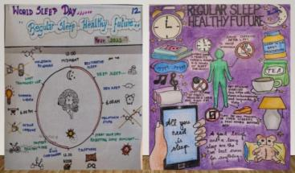
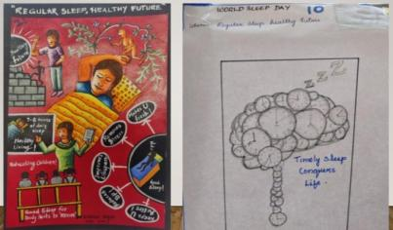 | 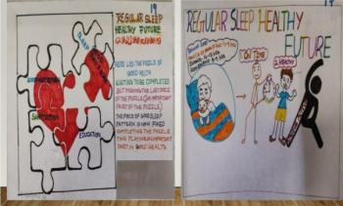
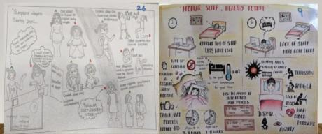

- International CME on SLEEP (22nd February 2021)
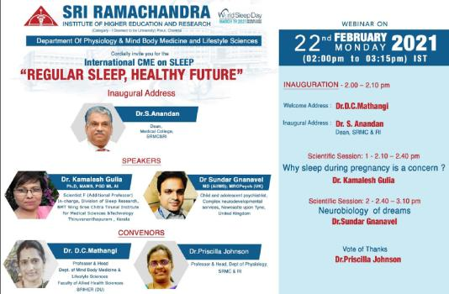
- The CME program commenced with the inaugural address by Dr.S.Anandan, Dean, Sri Ramachandra Medical College. Appreciating the organizers for choosing the relevant topics, he added his experience as a Dermatologist on one of his research study on psoriasis which not only had neuropsychiatric component but it positively correlated with lack of sleep and dermatological manifestations.
- Session : 1 –
- Dr.Kamalesh K Gulia, scientist, additional professor, division of sleep research, BMT wing Sree Chitra Tirunal Institute for Medical sciences Technology.
  - The speaker described the various sleep components and patterns of sleep cycle. She explained the normal physiological changes occurring pregnancy and it influence on the sleep pattern. She enlightened the audience on the various basic science research ongoing in this field.

- Session: 2 - Neurobiology of Dreams
- Dr. Sundar Gnanavel, child and adolescent psychiatrist.
- The speaker explained that the definition of dreams is a very complex one. He pointed out that dreams have different physiological as well as psychological significance and people spend about 6 years of their lifetime in dreams. Dreams mature and assume various patterns as the age advances. Therefore, dreams of children, adolescents or adult have different events embedded in them. He discussed on the various brain areas activated during the process of dreams. He concluded the session by outlining the importance of analysis of dreams as a corollary in the management of individuals with neuropsychiatric or psychological disorders.

This International CME had over 350 participants from across the country and few from other parts of the world too. The overall feedback on the program was highly encouraging.

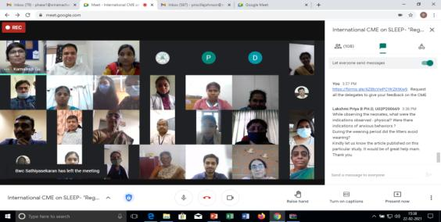

- March 19th, 2021, WORLD SLEEP DAY 2021

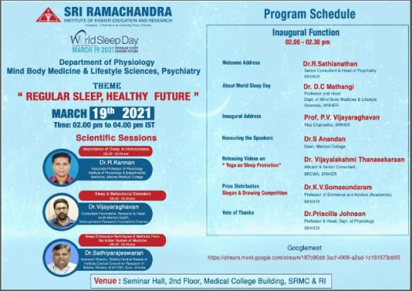

- Recent lifestyle modifications have made the general population around the world more prone for lifestyle orders. In order to create awareness on the importance of sleep, every year world sleep day is celebrated throughout the world in the month of March. The Department of Physiology, Mind Body Medicine and Psychiatry organized World Sleep Day CME on 19.03.2021 between 2-4pm at Seminar Hall, SRIHER with theme “Regular Sleep, Healthy Future”.
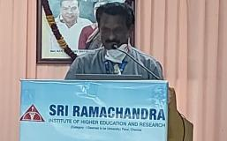
- The CME started with inaugural function having the administrative and senior academicians on the dais. Welcome address was delivered by Dr.Sathianathan, Prof. and Head of Psychiatry. He highlighted the role of sleep-in mental well-being and the various psychological derangements that could arise when the sleep gets disturbed. He welcomed the speakers and congratulated the students for their active participation in the event.

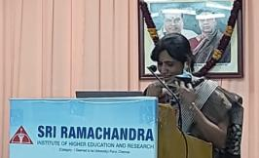
- Dr.D.C.Mathangi, Prof. & Head, Department of Mind Body Medicine spoke about the importance and significance of World Sleep Day. She highlighted the research on sleep during the Covid pandemic and lock down period. In her report on the WSD activities she highlighted on the “Sleep awareness video” which benefitted over 800+ school children, the research study on the impact of mobile phones on sleep quality among medical students, videos made by MBLS students on “Yoga for sleep promotion” and the various competitions for students to impress upon them the importance of sleep. Promotion through Social Media Handle of SRIHER through the support of IT was also informed.

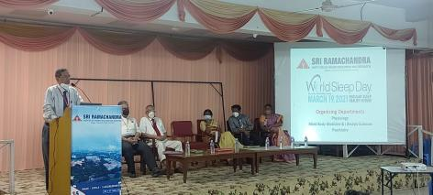
- The inaugural address was delivered by Vice chancellor Prof.P.V.Vijayaraghavan. He spoke about the “Sleep week” which was celebrated in western countries and how it has grown around the world as World Sleep day. He highlighted how sleeps among the health care workers are impacted by the pandemic. He emphasized the importance of “Early to bed and early to rise” and asked the students to sleep 6-8hrs/day and make good use of their early morning time for their academics and Dr.S.Anandan, Dean Medical College honoured the speakers of the CME.
- Videos were made by the students of MBLS dept titled “Yoga for sleep promotion”, “Yoga for Women’s health”. Both the videos were released by Dr.Vijayalakshmi Dhanasakaran, Senior consultant and Advisor, SRCWA. She explained the role of sleep and its complications that are witnessed in Pulmonological conditions and role of sleep in Lung health. She advised the students to be physically active and have a good sleep for a better future.
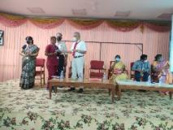
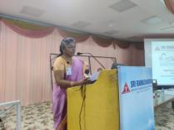
- As a part of the celebrations hand drawing and slogan competitions (Tamil/English) were conducted. The winners received e-certificate and prizes from Prof.K.V.Somasundaram, Professor of Eminence and Advisor (Academics). He also congratulated all the active participants and appreciated them.

- The winding part of the inaugural session – vote of thanks was delivered by Chief Organizer of the program, Dr.Priscilla Johnson, Professor & Head, Dept. of Physiology. The management, deans, faculties were wholeheartedly thanked and was followed by scientific session.

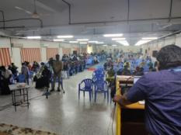
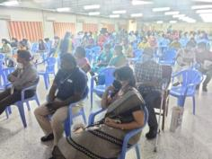
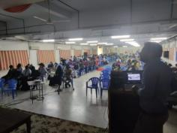

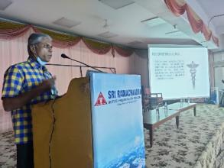
- The first talk of the day was on “Importance of Sleep in Homeostasis” by Dr.Kannan, Associate Professor of Physiology, Madras Medical College. He began his talk with interesting history of sleep sciences and explained the physiological basis of sleep and the role of various sleep centers in brain in regulating the same. He explained the role of various neurotransmitters especially the melatonin in regulating sleep-wake cycle. He highlighted the various causes of compromised sleep hygiene and its health effects.

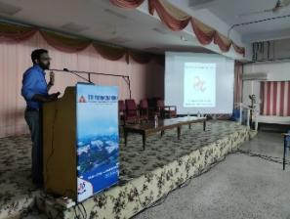
- This was followed by the talk on “Sleep and behavioural disorders” by Dr.Vijayaraghavan, Consultant Psychiatrist-Research, SCRAF. Being a coordinator for Youth Mental Health program he lucidly explained the various physiological changes that happens in brain and its effect on sleep and behaviour. He stressed on the psychiatric problems that have a sleep component and addressing it early helps in faster recovery. He emphasised on the sleep hygiene principles too.

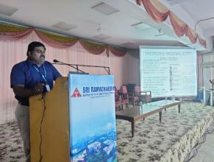
- Dr.Sathyarajeswaran, Asst. Director, Siddha Central Research Institute, spoke on “Sleep enhancers – Techniques and methods from the Indian system of Medicine”. He interlaced his talk with the quotes from the Tamil Siddha literature backed by quality scientific publication. Through his lecture he highlighted the importance of milk as sleep enhancer, massage therapy, duration of sleep as per siddha literature for various age groups, direction of sleep and other enhancers. He suggested a short day nap and to avoid a long duration of sleep which affects sleep-wake up cycle and brain’s health. He explained the sleep cycle in vaatha, pitha and kapha constitutions and asked the delegates to identify their constitution and sleep accordingly.

- Effective use of Social Media to promote importance of Sleep:
- Brief Talk on Importance of Sleep (English) – Dr.Priscilla Johnson & Dr.D.C.Mathangi : https://www.youtube.com/watch?v=My4l3pHIrSY

- Brief Talk on Importance of Sleep (Tamil) – Dr.Priscilla Johnson
https://www.youtube.com/watch?v=UDpyAYLVPgg&t=19s

- Creativity of students on social media https://www.facebook.com/SRIHER.Official/
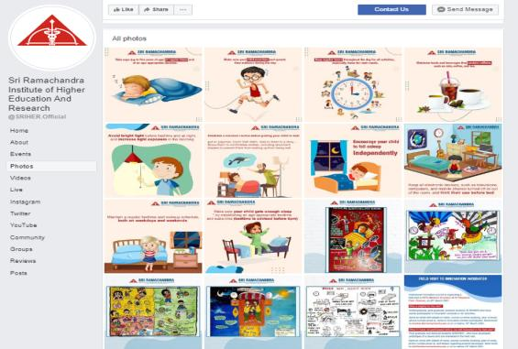
- Yoga for Good Sleep (Developed by Students)
  - YouTube: https://youtu.be/5oFpbIFjl_k
  - Facebook: https://www.facebook.com/SRIHER.Official/posts/1071576979983127
  - Twitter: https://twitter.com/SRIHER_Official/status/1375379243870339073
  - Linkedin: https://www.linkedin.com/feed/update/urn:li:activity:6781144989566042112

Thus, SRIHER through its multiple activities had made a sincere attempt to instil the importance of sleep in the minds of people across various age ranges.





