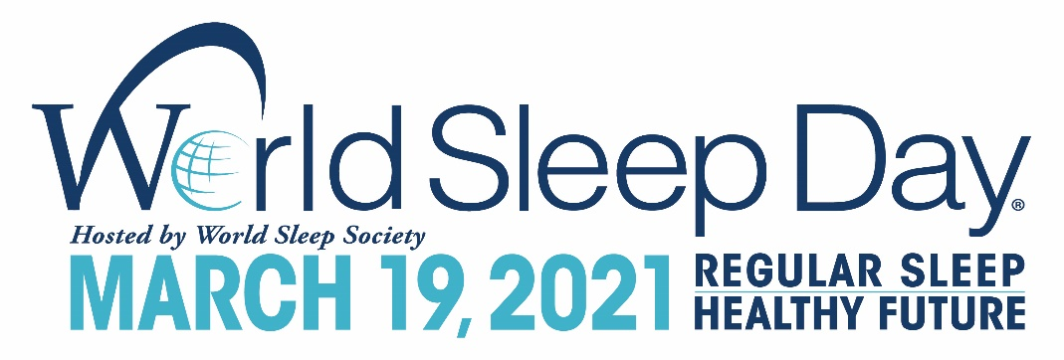

FOR IMMEDIATE RELEASE
World Sleep Society
+1.507.316.0084
info@worldsleepsociety.org
worldsleepday.org

World Sleep Day® Celebrates Healthy Sleep Worldwide on March 19

Delegates, scientists, artists and organizations spread awareness in dozens of countries

ROCHESTER, Minn., March 19, 2021 – World Sleep Society is excited to announce the 14th annual World Sleep Day® on Friday, March 19, 2021. World Sleep Day is an international call to action for sleep professionals, media channels and the public to celebrate the value of healthy sleep. The slogan and focus of this year’s World Sleep Day is “Regular Sleep, Healthy Future.”
“Regular Sleep, Healthy Future” is purposefully broad in meaning to facilitate a truly global event. On or around World Sleep Day, volunteer delegates across dozens of countries will hold official, public and free World Sleep Day activities promoting healthy sleep.

Resources on healthy sleep
Medical research has shown that stable bedtimes and rise times are associated with better sleep quality across all age groups. Regular sleepers have better mood, psychomotor performance and academic achievement. More information on sleep can be found in the World Sleep Day 2021 Toolkit. Sleep researchers and doctors worldwide comprise World Sleep Society, which will only promote credible, science-backed information about sleep.

World Sleep Society partners with musicians to spread awareness of healthy sleep

In addition to music’s broad appeal as an aid for relaxation, music can also be used as part of cognitive-behavioral therapy for insomnia (CBT-I). Dr. Charles Morin, a leading expert in CBT-I, says “Sleep problems, particularly insomnia, have dramatically increased (two to threefold) since the beginning of the pandemic, along with a significant increase in stress and anxiety. Make sure to schedule time to relax and enjoy pleasurable and relaxing activities, especially before bedtime. For some it may be music, reading, mindfulness—the important thing is to make time.”

Music partners for World Sleep Day this year include Verve Label Group, which specializes in classical and jazz, and Rosey Chan, a multimedia artist based in London. Both are releasing new music oriented toward relaxation and sleep on World Sleep Day. Verve Label Group will be releasing a playlist of 18 new tracks from artists including Max Richter, Chad Lawson, Ludovico Einaudi and more. Rosey Chan is releasing a new single, “Water is Life,” from her March 26 album Sonic Apothecary, which is composed to promote relaxation, wellness and assist with falling asleep.

Partnering to advance sleep health
World Sleep Society has partnered with organizations including DeRUCCI, Zepp, AmLife, Chemipharm Group, Sleep Country, BodiMetrics and Estée Lauder to promote World Sleep Day internationally.

Mr. Lou Fang of DeRUCCI says, “We believe the key to achieve regular sleep is to enhance sleep quality. To be specific, to create a comfortable sleep environment to extend deep sleep. Our expert teams have been working on the research and developing new technologies and products to help people achieve this goal ever since 2004. Now, after partnering with World Sleep Day, DeRUCCI will integrate resources to continue to extend the research on this topic. We will always stick to our mission to let people sleep better.”

Mr. Lew Mun Yee, founder of AmLife, states, “At AmLife, we believe sleep is a vital component of every person’s overall wellness. Many of us in the current modern society have been constantly facing the matters of sleep deprivation and/or sleep disorders. We, as a leading company in the sleep wellness industry, will continue to promote the importance of sleep and raise public awareness of sleep.”

Dr. Meir Kryger, member of BodiMetrics Medical Advisory Board, says, “Oxygen is vital for life! Being able to measure blood oxygen levels accurately, continually, and conveniently – day or note. Imagine the clinical possibilities.”

Join the cause and watch the world unite on March 19 to celebrate sleep and its fundamental significance for human health.

###

About World Sleep Society
World Sleep Day is organized by World Sleep Society, an international association whose mission is to advance sleep health worldwide. World Sleep Society hosts a biennial scientific congress on sleep medicine aiming to globally connect sleep professionals and researchers to advance current knowledge on sleep. Follow the excitement on Twitter @_WorldSleep and facebook.com/WASMF.

About DeRUCCI
DeRUCCI is a global industry-leading bedding product design and manufacture company. Founded in 2004, DeRUCCI has been committed to the mission of “Let people sleep better” and has brought its intelligent healthy sleep system to users from more than 40 countries and regions worldwide. To improve people’s quality of sleep is what keeps the company progressing today.

About ZEPP
As a professional-grade brand for the digital management of users’ well-being, Zepp leverages its leading AI algorithmic system to bring digital health solutions to people around the globe. From traditional health and exercise monitoring to analysis and early health-status warnings, Zepp is committed to helping users improve their quality of life. Zepp believes in the use of technology to better manage our well-being and help everyone enjoy a more fulfilling life. Therefore, Zepp’s mission is to “continuously develop new technologies and use accurate data-analysis capabilities to help people manage their own health.” Learn more at https://www.zepp.com/en/zepphealth

About AmLife
AmLife International Sdn. Bhd. established its sleep healthcare business to help consumers achieve optimal health in their daily sleep as well as enjoy the wonderful health-lifting, sickness-preventing and recuperative effects of its products. AmLife has pioneered the combination of bedding equipment and Japan’s state-of-the-art technology to expand the unlimited potential of the sleep healthcare market, providing a brand-new health solution for modern-day people, which they can use every day.

About Chemipharm Group
Chemipharm is an Egyptian pharmaceutical company established in 1972. They have two state of the art manufacturing hubs in Egypt & Morocco, which cover all widely used pharmaceutical forms. They are experts in the development of unique, valuable products and healthcare solutions, in addition to a wide range of latest-generation generic molecules, augmented with dedicated marketing and distribution teams.

About Sleep Country
Sleep Country is Canada's leading omnichannel specialty sleep retailer, with a national brick-and-mortar footprint and robust eCommerce platforms dedicated to supporting the health and wellbeing of Canadians by matching each customer to their best night's sleep. Sleep Country offers a diverse and innovative assortment of sleep essentials from mattresses and beds to pillows, sheets, protectors and more. For more information, visit www.sleepcountry.ca
About BodiMetrics
BodiMetrics is dedicated to developing and delivering innovative devices, applications and algorithms that provide remote diagnostics and monitoring to extend rural care, set individual health goals, foster ongoing wellness and improve adherence to treatment protocols in self-managed and third-party assisted care programs, such as congestive heart failure (CHF), asthma, COPD, sleep apnea, weight management and family wellness. Visit www.bodimetrics.com or contact them at (844) 744-8800 for additional information.

