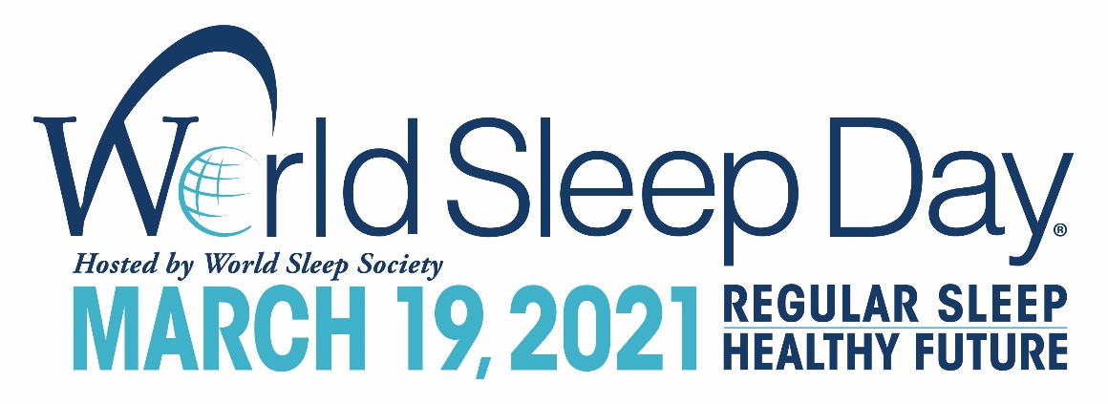

FOR IMMEDIATE RELEASE
World Sleep Society
+1.507.316.0084
info@worldsleepsociety.org
http://worldsleepday.org/

CELEBRATE WORLD SLEEP DAY® ON MARCH 19
TO ADVANCE SLEEP HEALTH WORLDWIDE

ROCHESTER, MN – January 2, 2021—World Sleep Society is issuing a global call to action about the importance of healthy sleep. Friday, March 19, 2021 is the 14th annual World Sleep Day®. Created and hosted by World Sleep Society, World Sleep Day (WSD) is an internationally recognized awareness event bringing researchers, health professionals and patients together to recognize sleep and its important impact on our health.

World Sleep Day 2021 will incorporate the slogan, ‘Regular Sleep, Healthy Future,' highlighting sleep's important place as a pillar of health, allowing for a healthier future thanks to regular, quality sleep. This focus is purposefully broad in meaning, surrounding the message that quality of life can be improved with healthy sleep. Conversely, when sleep fails, health declines, decreasing quality of life. Sound sleep is a treasured function. World Sleep Society has compiled ten tips for healthier sleep. These recommendations for children and adults can be viewed on worldsleepday.org under resources.
WSD is co-chaired by Lourdes DelRosso, MD, MS, Associate Professor of Pediatrics, Associate Sleep Medicine Fellowship Director at University of Washington and Professor Fang Han, MD of The Sleep Center, Peking University People’s Hospital in Beijing, China. WSD co-chair Dr. Lourdes DelRosso expresses, “Sleep medicine physicians do not only treat sleep disorders, we also have a responsibility to promote sleep health. We know that regulating the time you go to sleep and wake up each day is associated with better sleep quality and length. Regular sleep is a great way to start off each day in a healthy way—paving the way for a healthier future.” WSD co-chair Professor Fang Han, states, “We can apply the following principles to achieve regular sleep. First, exposure to natural daylight helps set the body clock. Second, building more activity into everyday life and keeping regular exercise. Third, switching off fully before bedtime will allow for relaxation. Finally, having positive emotions will help with a better overall health and wellbeing, as well as good sleep.”
“It is easier to achieve regular sleep when we set ourselves up for success,” explains Michael A. Grandner, PhD, MTR. “This means getting up at a regular time each day, preferably followed by bright light exposure and some movement to send a reliable daytime signal. Then, in the evening, budgeting sufficient time to wind down and detach is critical for being able to initiate sleep. Finally, maintaining good stimulus control (getting out of bed if you can't sleep) will help build some resilience in the system. Taking these three things together—starting the morning, setting up the evening, and inoculating against nighttime disturbances—will help in the search for regular sleep.”

CALL TO ACTION
To participate in World Sleep Day, consider:
- Organizing an event to create excitement and generate interest in World Sleep Day.
- Circulating the official press release with sleep experts and local media.
- Distributing sleep patient literature such as booklets, leaflets and newsletters.
- Finding other ideas at worldsleepday.org.
- Spreading the word on social media about #WorldSleepDay.

More information can be viewed on worldsleepday.org/get-involved/plan.
Sleep is a basic human need—a crucial component of survival, much like breathing, eating a healthy diet or getting enough exercise.

CONTACT
Allan O’Bryan, World Sleep Society Executive Director: obryan@worldsleepsociety.org

###

About World Sleep Society
World Sleep Day is organized by World Sleep Society, an international association whose mission is to advance sleep health worldwide. World Sleep Society hosts a biennial scientific congress on sleep medicine aiming to globally connect sleep professionals and researchers to advance current knowledge on sleep. A virtual meeting is also underway with details on worldsleepsociety.org. Follow the excitement on Twitter @_WorldSleep and facebook.com/WASMF.

