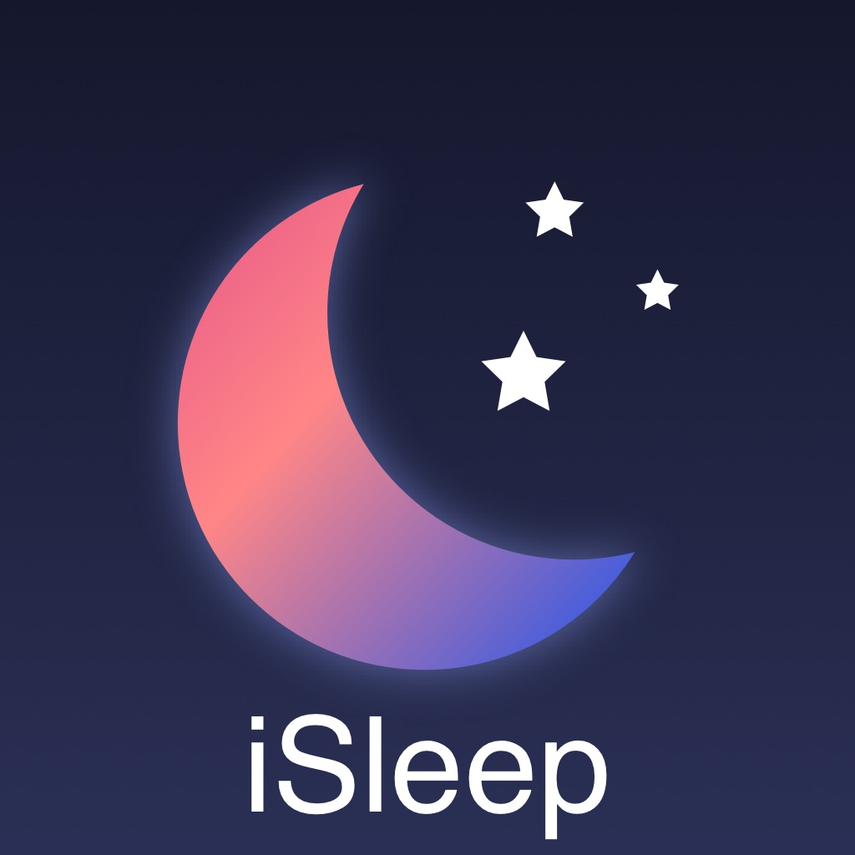
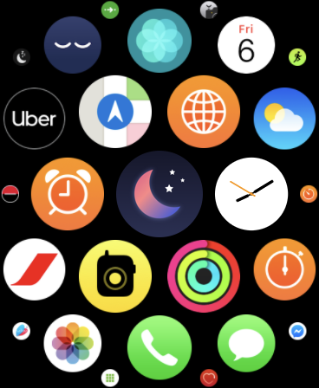

COMUNICATE: 13 March 2020.
WORLD SLEEP DAY

ISleep the first sleep application on Apple Watch validated
By sleep specialists is launched worldwide this week just at time for the world sleep day.

Apple (Cupertino USA) has validated this weekend and launched on the Apple-store the Apple Watch version of the iSleep watch, the first Apple-Watch application dedicated to sleep scientifically validated by two French sleep specialists. As a result of an innovation project, the new application allows everyone to know their sleep time and quality and to monitor their snoring, two essential factors of our health. A new public health tool according to its two designers.
Why is it so important to know how long you are sleeping at night and how much you are snoring?
In recent years sleep has been identified as a determinant of health as important as nutrition, physical exercise and stress in the prevention of metabolic and psychiatric diseases. According to Professor Damien LEGER, co-founder of iSommeil: “A quarter of adult’s worldwide sleep less than 6 hours a day. We know that sleeping less than 6 hours increases the risk of overweight, obesity, cardiovascular disease, depression, road accidents. Optimizing your sleep time is essential.”
Snoring is not only a domestic nuisance, difficult for the spouse to bear, but also a risk factor for sleep apnea syndrome, which affects nearly one in 10 adults worldwide. Apnea syndrome also increases the risk of hypertension and heart disease. It seriously impairs sleep quality and promotes drowsiness, including driving

Sleep on the Apple Watch is an essential novelty.
Apple reportedly sold 31 million Apple Watch worldwide (CNN News 14-02-2020) and the Apple Watch makes it possible to monitor its health and in particular its physical activity (number of steps, sports training, calories spent), but also heart (resting heart rate and stress and the first wrist electrocardiogram developed by researchers from Stanford, California). With iSleep, it is now possible to know every night, its precise total sleep time, its time spent in bed, the percentage of snoring at night, the sleep efficiency and the heart rate during sleep, which are all health determinants validated by the sleep specialists.
- Total sleep time: the sleep duration from the first phase of sleep to the final awakening cut off from the waking time during sleep. (normal : from 7 to 8:30 hours, at risk if less than 6 hours)
- Time spent in bed between the extinguishment of the lamps and the awakening, which allows knowing its sleep rhythms. (recommended :no more than 8 hours in the adult)
- The snoring sound level at night in dB, the frequency of stops of snoring, making it possible to envisage a risk of sleep apnea.
- The Sleep efficiency, which is the ratio of total sleep time to time spent in bed (Normal: if greater than 90%).
It will be therefore possible, for everyone, to easily know his sleep throughout his nights, and to communicate his results (via the medical record on iPhone) to relatives and to her/his doctor, and possibly to associate them with the ones on activity and cardiovascular data.

From the iSleeping mobile app to the iSleep app on Apple Watch.
The iSleeping mobile app (in 2017 version on IOs, and 2012 on android) is free and has already been downloaded by more than 1,200,000 people worldwide, of whom 350,000 use it regularly. It also allows via the telephone to appreciate his sleep time and his snoring. It is from the expertise of this application that sleep specialists designers have developed the iSleep application on Apple Watch. The new algorithm created for Apple Watch can now, thanks to the movements and heart rate, help you measure, manage and improve your sleep. Its automatic and precise tracking gives you a complete overview of your night: measuring your sleep time, your heart rate, your breathing, you’re snoring. iSleep sending notifications to prepare you for sleep and a better awakening.

“With the help of the iSleep App and the holistic features of Apple Watch, the user becomes an actor in his health since he can now communicate his results in connection with the Apple Santé platform to his doctor or a sleep specialist, according to Dr Maxime Elbaz, co-founder of iSommeil.”
Tips for using iSleep on Apple Watch.
What tips to use iSommeil on Apple Watch.
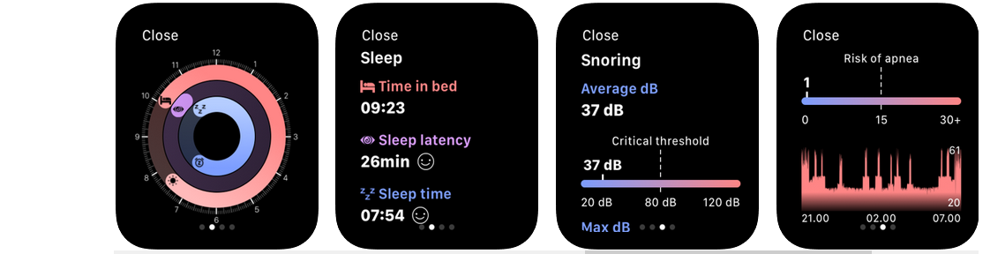
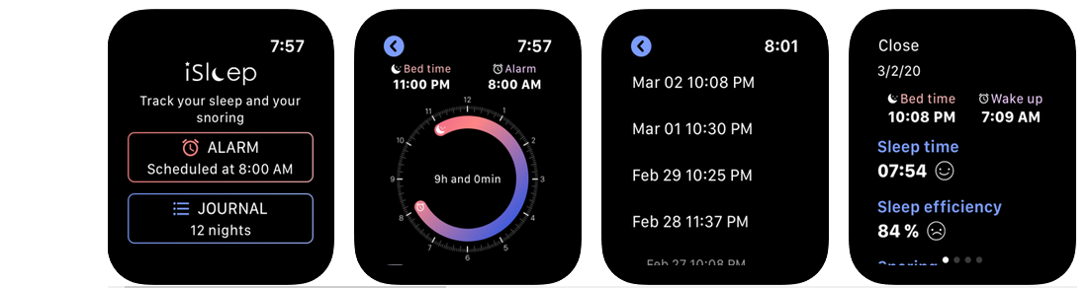
It’s VERY SIMPLE, download iSleep and let it GUIDE you, Complete your bedtime, your wake-up time and GOOD NIGHT

CONTACTS PRESS-CONTACT
iSleep Watch: Maxime ELBAZ Mobile+33 6-98-20-26-01 maxime.elbaz@isommeil.io
download on :
https://apps.apple.com/us/app/isommeil-watch/id1484802203: 40, 99 US $

On iSleep DESIGNERS AND SLEEP SPECIALISTS:
Damien LEGER
M.D., Ph.D., Professor of Medicine at the University of Paris and founder manager of the Hôtel-Dieu Sleep and Vigilance center in Paris, France, APHP, and co-director of the research team 7330 VIFASOM, Damien LEGER is a sleep specialist in Paris and internationally recognized sleep researcher, as the author of more than 170 international publications and 6 books. An expert with the World Health Organization, the European Community, the European Space Agency, the French Ministries of Health, Transport, the Environment, National Education and Defense, he is former President of the French Sleep Research and Médecine Society (SFRMS) an member of the American Academy of Sleep medicine (AASM).
Maxime ELBAZ
PhD in neuroscience and specialist in sleep and e-Health. He is the Technical Director of the Hôtel-Dieu Sleep and Vigilance center in Paris, France, and researcher of the EA7330 VIFASOM research team at the University of Paris. He is a member of the France e-Health Council. He is co-founder of the eHealth University Diploma for Connected Medicine at the University of Paris. He holds the Certificate Course of Sleep Medicine from Stanford USA. He founded the French Sleep Technicians Society and was President of the European Society of Technologists.

