World Sleep Day
II Scientific Meeting from Agreste Alagoano of Sleep Disorders (II ECAADS)
I Week for the Prevention of Sleep Disorders

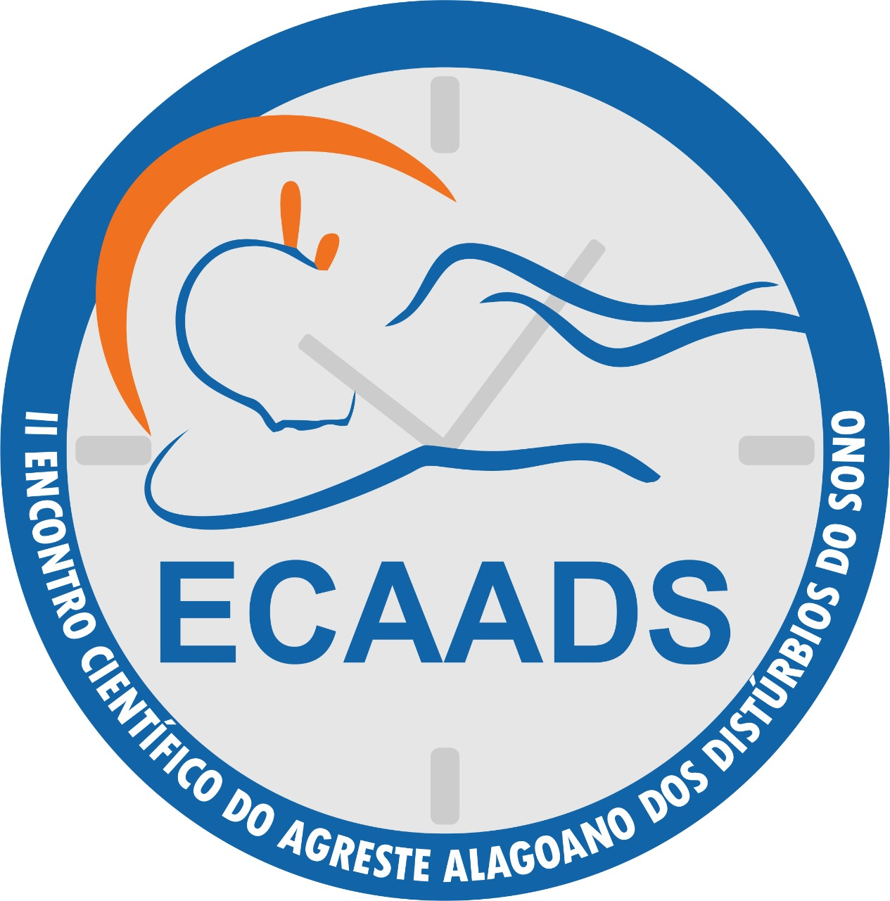
Training with health professionals in the city of Arapiraca
Theme: Improving sleep quality!
Place: CRIA Auditorium
Day: 02/12/2020 (Wednesday)
Time: 8 am -12h pm
Developed by: Federal University of Alagoas (Nursing course)
The World Health Organization (WHO) defines “health” as a state of complete physical, mental and social well-being, and not simply the absence of disease or illness. Sleep deprivation and poor quality sleep directly affect professional activities, as they interfere with concentration, motivation and personal relationships. Therefore, knowing how to improve our sleep pattern is fundamental for both personal health and productivity at work.
So, within the II Scientific Meeting from Agreste Alagoano of Sleep Disorders (II ECAADS): "Sleep well, live well and age well" and I Week of Prevention of Sleep Disorders, we propose a morning of lectures for health professionals in the city, with the activities described below:

8:30 a.m.: Opening lecture: “Sleep well, live well, age well”
Prof. Christiane Cavalcante Feitoza
9 a.m.: Lecture: "Anxiety and Sleep Quality"
Psychologist Karla Thiala Melo Silva
9:30 a.m.: I dialogue circle
9:40 a.m: Coffee break
10 a.m: Lecture: “Chronodysruption and endocrinometabolic changes: impact of diet on the regulation of the circadian cycle”
Nutritionist Jean Marcos
10:30 a.m.: Time for questions.
10:45 a.m.: Lecture and relaxation activity: “Live Calmly”
Yoga Tutor Renata Barbosa.
11:15 a.m.: II dialogue circle
11:45 a.m.: Closing

