World Sleep Day
II Scientific Meeting from Agreste Alagoano of Sleep Disorders (II ECAADS)
I Week for the Prevention of Sleep Disorders

Scientific program – II ECAADS

Thursday (02/13/2020 – Morning)
08:00 a.m. - 08:30 a.m: Registration and accreditation
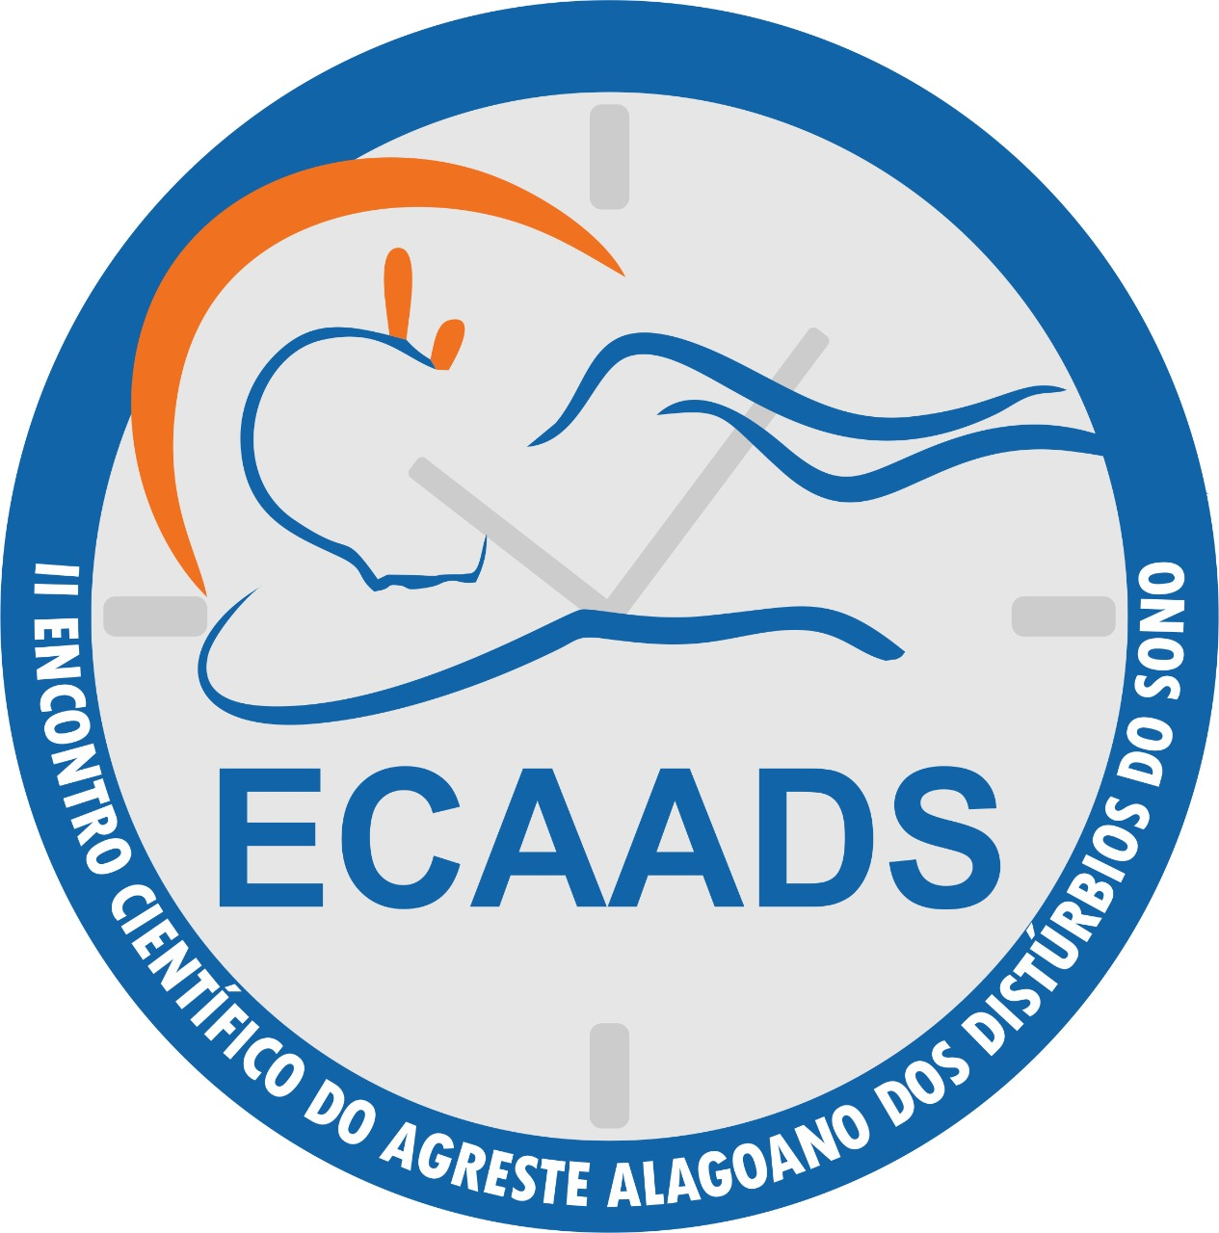
08:30 a.m. – 09:00 a.m.: Welcome ceremony
09:00 a.m. – 09:40 a.m.: Sleep x Physiological paradise: sleep, dream and be happy. Only that?
Prof. PhD. Luiza Antas Rabelo (UFAL)
09:40 a.m. - 10:20 a.m.: Sleep x Physical exercises
Prof. MSc. Douglas Henrique Bezerra Santos (UFAL)
10:20 a.m. - 10:40 a.m.: Coffee Break
10:40 a.m. - 11:20 a.m.: Sleep x Medicines
Prof. PhD. Elaine Virgínia Martins de Souza Figueiredo (UFAL)
11:20 a.m. – 12:00 a.m.: Sono x Drugs (Exposure to drugs in pregnancy and the effects on sleep and behavior of the newborn)
Prof. MSc. Renise Bastos Farias Dias (UFAL)

Thursday (02/13/2020 – Afternoon)
14:00 p.m. – 14:40 p.m.: Sleep x Child Exposure Time to smartphones
Prof. PhD. Cleriston Izidro Dos Anjos
14:40 p.m. – 15:20 p.m.: Sleep x Anxiety: what is the relationship and how does neuropsychology explain? "
Psychologist Karla Thiala Melo Silva
15:20 a.m. – 15:40 a.m.: Coffee Break
15:40 p.m. – 16:20 p.m.: Sleep x Newborns
Nurse Yrys Rayanny Macêdo Barbosa
16:20 p.m. – 17:00 p.m.: Sleep x memory
Prof. MSc. Rafael Danyllo da Silva Miguel

Friday (02/14/2020 - Morning)
8:30 a.m. – 9:20 a.m.: Sleep x Sports Performance
Prof. PhD. Arnaldo Tenório da Cunha Jr
9:20 a.m. – 10:00 a.m.: Sleep x Genetics: What is the problem with the evening?
PhD. Diego de Siqueira Figueiredo (UFAL)
10:00 a.m. - 10:20 a.m.: Coffee Break
10:20 a.m. – 11:00 a.m.: Sleep x Apnea in children: when to suspect?
Doctor Katiane Wanderley Rocha (Otorhinolaryngologist, Sleep Medicine Specialist)
11:00 a.m. – 11:40 a.m.: Sleep x Aging
Doctor Rossana Araújo Silvestre (Neurologist)

Friday (02/14/2020 – Afternoon)
14:00 p.m. – 16:00 p.m.: Presentation of works E-Posters
CCME rooms

