World Sleep Day
II Scientific Meeting from Agreste Alagoano of Sleep Disorders (II ECAADS)
I Week for the Prevention of Sleep Disorders

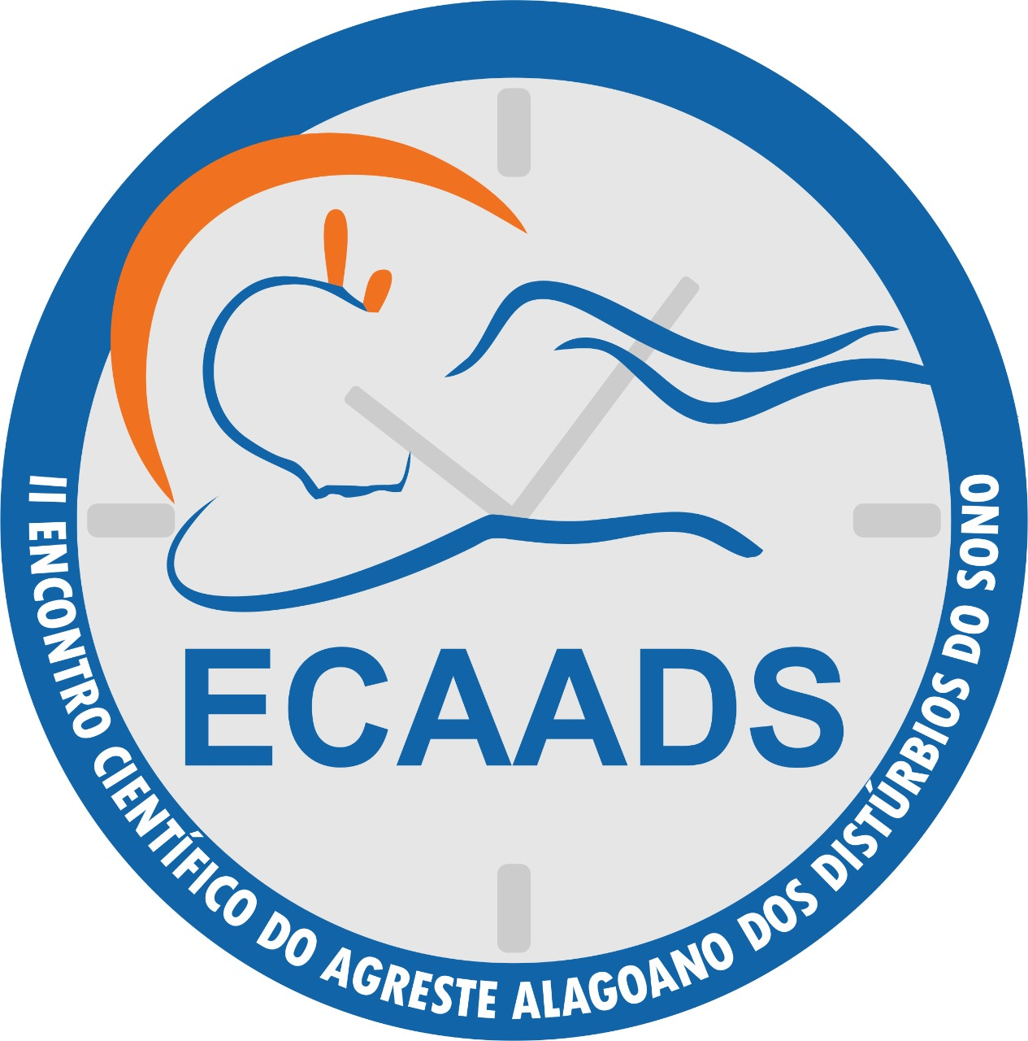
Action in the Square

Theme: Sleep Quality available to everyone!
Day: 02/10/2020 (Monday)
Hours: 9 am to 2 pm
Developed by: Federal University of Alagoas (Nursing course)
Place: Luiz Pereira Lima Square (Arapiraca, Alagoas, Brazil)
Services offered:
Activities to promote health and sleep quality
Glucose Checking
Blood Pressure Measurement
Performing BMI
Rapid tests
Itnerant library
Recreation activity, gymnastics

Contributors:
City hall of Arapiraca
SESC

