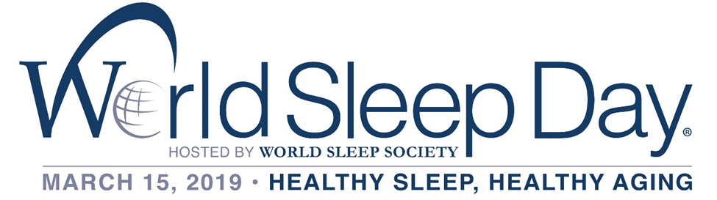
WORLD SLEEP DAY® - ACTIVITY IN TRINIDAD AND TOBAGO
This year, the delegate for Trinidad and Tobago, Mr. Gregory Arneaud (Clinical Director – iSD Health Solutions), collaborated with three major pharmacy chains within Trinidad and Tobago.
- Massy Stores Pharmacy (9 locations),
- Starlite Pharmacy (3 locations) and;
- SuperPharm Pharmacy (9 locations).
This collaboration, empowered the population to have access to the first and only disposable Home Sleep Apnea Test, the Apnea Strip™ across a total of 21 locations throughout Trinidad and Tobago, in addition to free consultations provided by Mr. Arneaud and his team at iSD Health Solutions.
The Apnea Strip™ is a clinically proven, inexpensive screening device that can determine if a person is at high or low risk for Sleep Apnea. It is FDA approved to screen for Sleep Apnea and is designed to be worn during sleep in the comfort of your home. Sleep Apnea is a life-threatening condition that often goes undiagnosed. Doctors usually cannot detect the condition during routine office visits. Also, no blood test can help diagnose the condition.
This collaborative effort did not only bring greater awareness to the sleep disorder Obstructive Sleep Apnea (OSA) but also aided in educating the public about the steps that can be taken to treat OSA within Trinidad and Tobago.
iSD Health Solutions also partnered with Dr. Raj Kapoor – Founder of the Clinic in a Bag – Rijuven product to bring greater awareness to Physicians, Nurses, Pharmacists and other Medical Practitioners about the importance of Sleep, Sleep Disordered Breathing and its relationship with Non-Communicable Diseases.
Mr. Arneuad provided two free seminars on World Sleep Day which was held at the Hilton Trinidad and Conference Centre, on World Sleep Day. A total of 32 Medical Practitioners were in attendance throughout the day. The seminars touched on the Clinic in a Bag and its uses, and how it will revolutionize healthcare in Trinidad and Tobago, from Wakeful to Sleep Testing, as well as the importance of Sleep and addressing Sleep in Trinidad and Tobago: : All around the theme of “Healthy Sleep, Healthy Aging.”
These seminars were sponsored by Blue Waters Products Limited. Like Water, Oxygen is Essential for Life! Oxygen is a requirement to sustain life and isn’t something you can touch, feel, smell or taste but is as important as proper Hydration (H2O) and restorative sleep for overall good health and quality of life. Blue Waters Products Limited understood just how important this is and partnered with this initiative for World Sleep Day.

Partners
