Media Coverage
https://www.facebook.com/1806086089693164/posts/2005075196460918/

https://karnalbreakingnews.com/health/awareness-seminar-organized-at-the-karnal-medical-center-on-the-occasion-of-international-sleep-day/

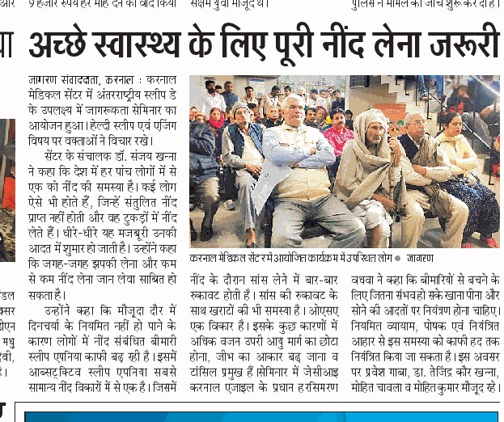 At Karnal Medical Centre, Karnal, Haryana, India

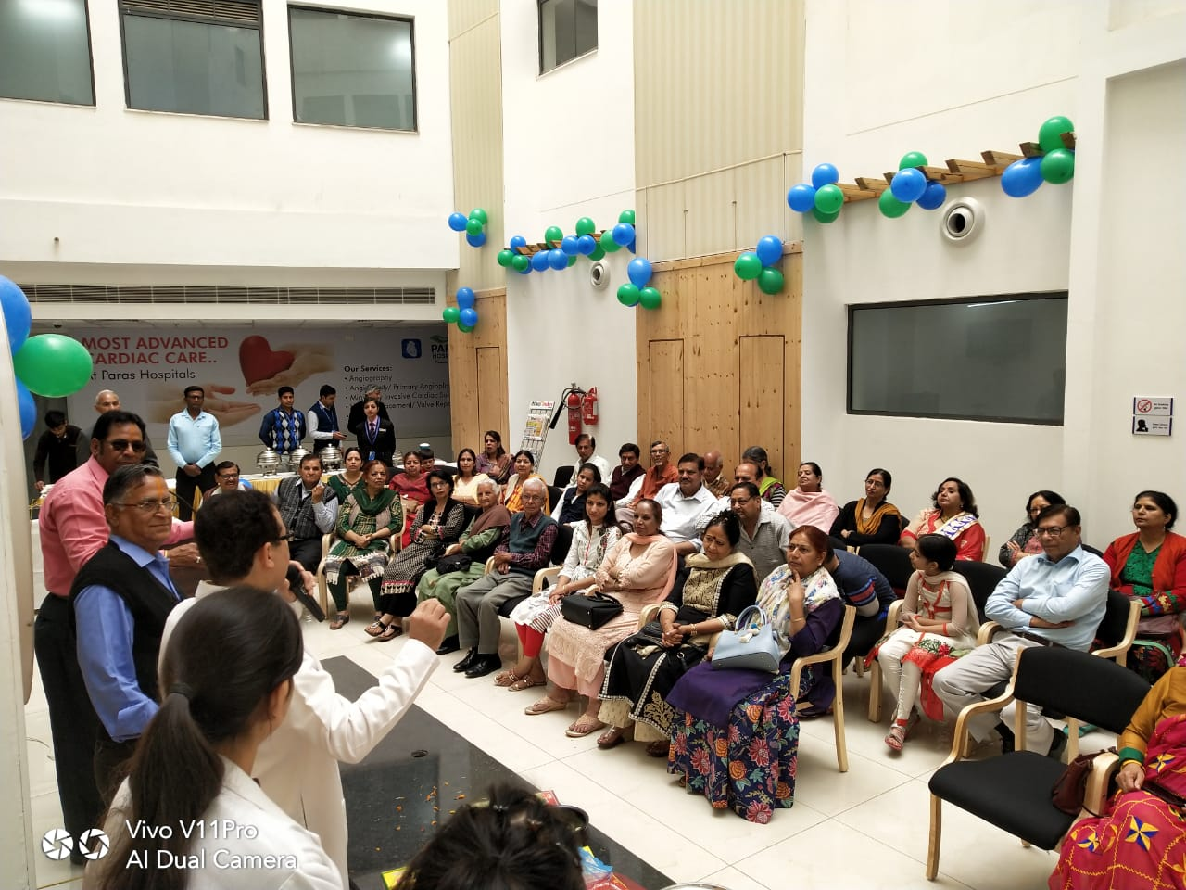
At Paras Hospitals, Panchkula, India
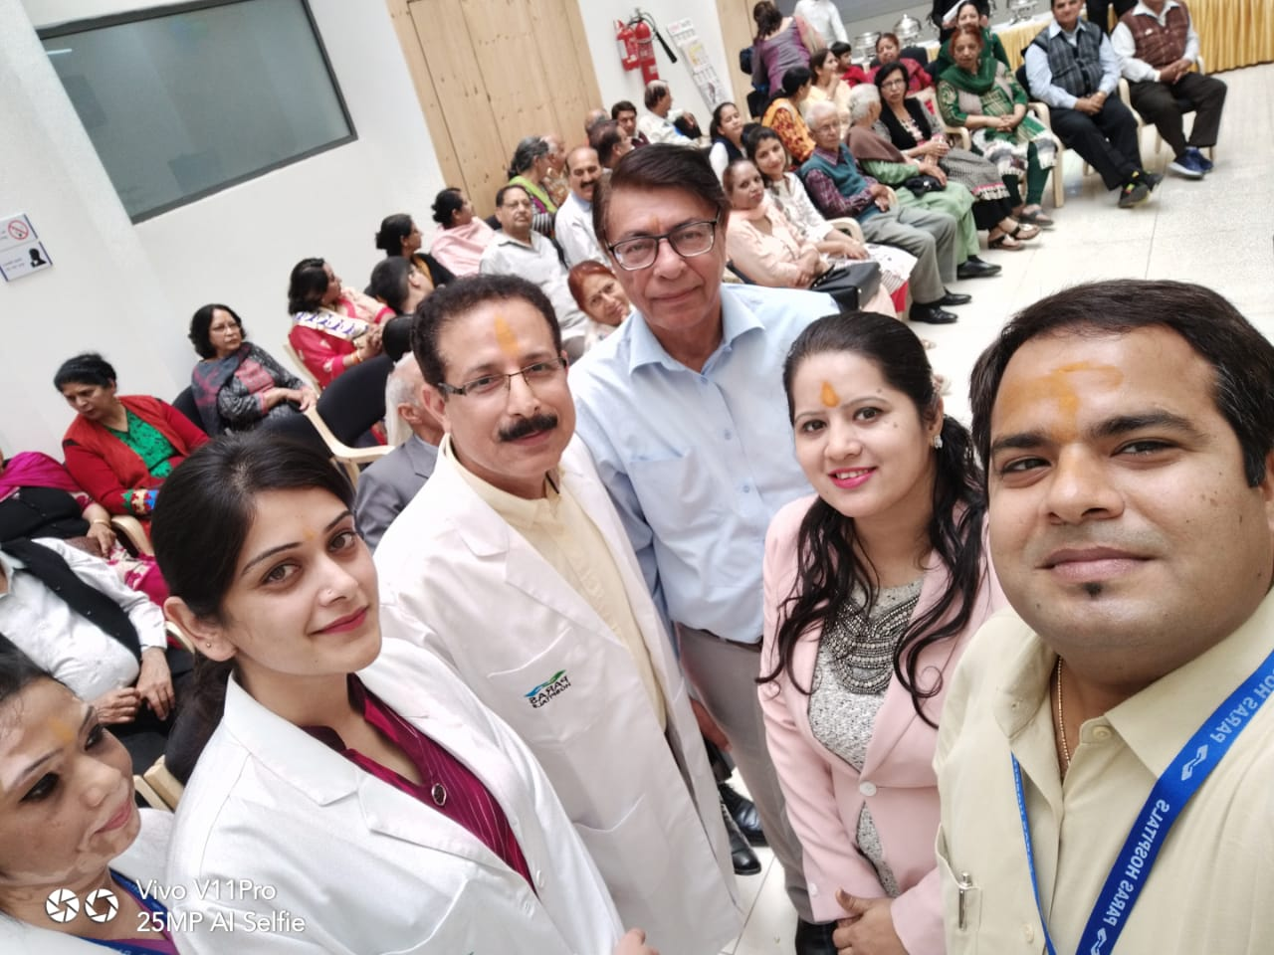

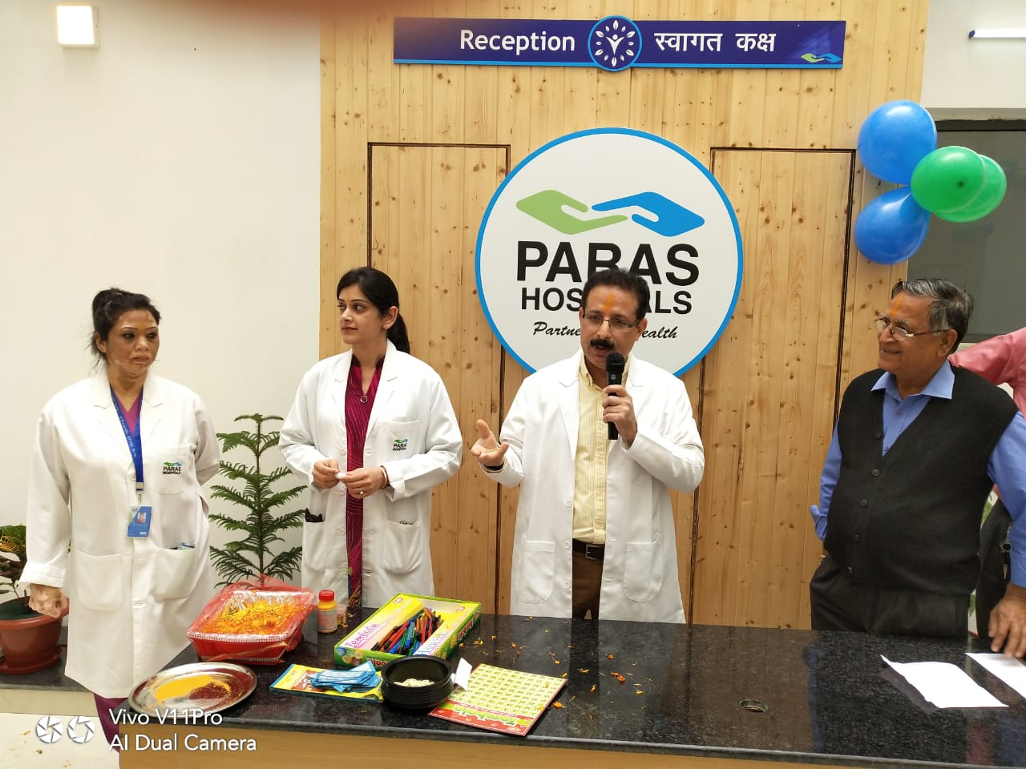

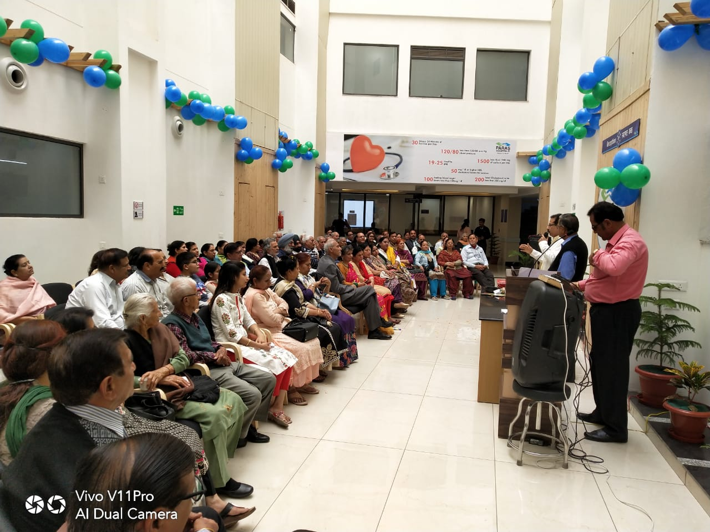
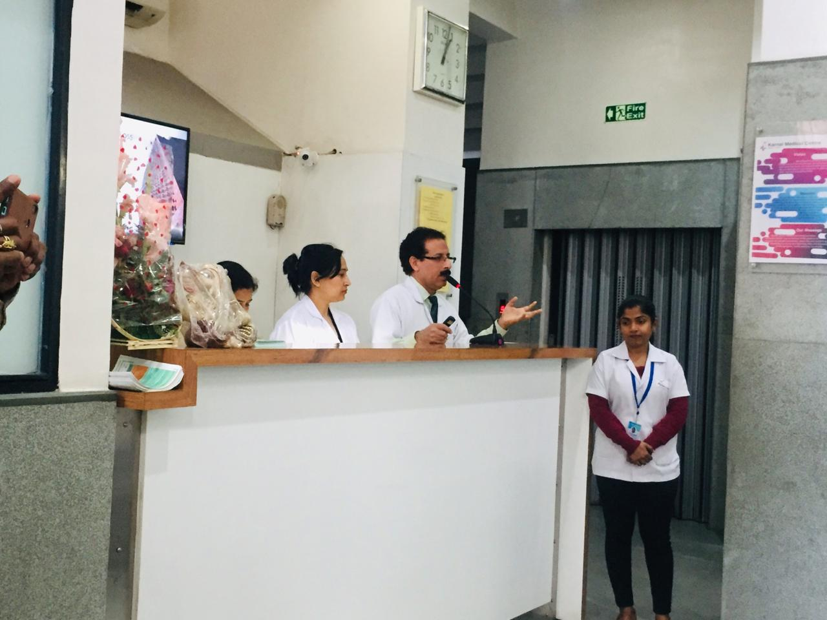
At Karnal Medical Centre, Karnal, India


