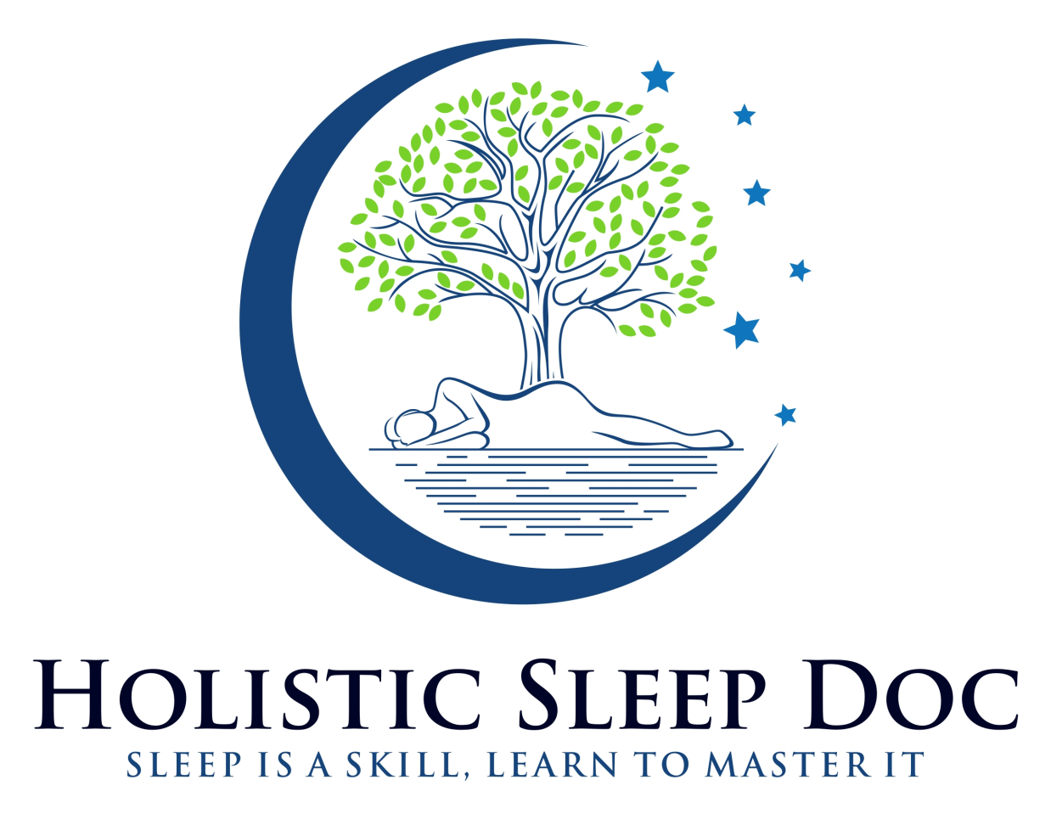
WHY SLEEP IS MORE IMPORTANT THAN DIET AND EXERCISE

If you skip eating or exercising for 24 hours
it won’t impair your health as severely as
skipping sleep for 24 hours.

